Chapter
Aggregate Scheduling

Discussion Questions
1. Aggregate planning is concerned with the quantity and timing of production for the intermediate future; typically encompasses a time horizon of three to eighteen months.
2. Aggregate means combining the appropriate products and resources into general, or overall, terms.
3. Strategic objectives: minimize cost over the planning period, smooth fluctuations in work force, drive down inventory levels for time-sensitive stock, and meet a high level of service regardless of cost. Cost minimization is the most often treated quantitatively and is generally the most important.
4. With a chase strategy production rates or work force levels are
adjusted to match demand requirements over the planning horizon.
5. A pure strategy is one that varies only one factor—for example, maintain a constant work force level or maintain a constant inventory. Trade-offs are ignored.
6. Level scheduling is an aggregate plan in which daily capacities are uniform from month to month. The underlying philosophy is that stable employment leads to better quality, less turnover, less absenteeism, and more employee commitment.
7. Mixed strategy is a planning approach in which two or more options, such as overtime, subcontracting, hiring and layoff, etc., are used. There are both inventory changes and work force and pro-
duction rate changes over the planning horizon. Typically, mixed strategies are better (result in lower costs) than pure strategies.
8. The advantage of varying the size of the workforce as re-quired to adjust production capacity is that one has a fundamental ability to change production capacity in relatively small and precise increments. The disadvantages are that a ready supply of skilled labor is not always available, newly hired personnel must be trained, and layoffs undermine the morale of all employees and can lead to a widespread decrease in overall productivity.
9. Mathematical models are not more widely used because they tend to be relatively complex and are seldom understood by those persons performing the aggregate planning activities.
10. Aggregate planning in services differs from aggregate planning in manufacturing in the following ways:
- Most services are perishable and cannot be inventoried.
It is virtually impossible to produce the service early in anticipation of higher demand at a later time.
- Demand for services is often difficult to predict. Demand variations may be more severe and more frequent.
- Services are more customized than manufactured goods and can be offered in many different forms. This variability makes it difficult to allocate capacity. Units of capacity may also be hard to define.
- Because most services cannot be transported, service capacity must be available at the appropriate place as well as at the appropriate time.
- Service capacity is generally altered by changes in labor, rather than by equipment or space, and labor is a highly flexible resource.
11. The master production schedule (MPS) is produced by disaggregating the aggregate plan.
12. Graphical aggregate planning methods, while based on trial and error, are useful because they require only limited
computations and usually lead to optimal solutions.
13. Limitations of the transportation method include that it does not work well when one attempts to include the effect of hiring and layoffs in the model.
14. Yield management adds another set of decisions to the
aggregate plan, to capacity planning, and to scheduling. However, of these yield management issues, the aggregate plan may be the one least affected. Auto rental companies, airlines, and hotels now all vary “inventory” (autos, seats, rooms) and prices to reflect ways to maximize their yield (profit). Lead time (vacationers price shop more and are willing to do so earlier), days of the week, seasons, holidays, and conventions all impact the yield. In many cases, the aggregate supply is the least affected.
Ethical Dilemma
1. From the airline’s point of view, revenue (yield) management is crucial. Moreover, many firms, including hotels, restaurants, and universities practice revenue management. A good class discussion can be generated by asking students to discuss how other organizations practice yield management without all of the publicity (often adverse publicity) that airlines receive.
Hotels have various approaches, from weekend specials, to “points,” to computerized pricing to adjust to daily volume changes.
Restaurants have coupons, early bird specials, and special prices on slow nights. Huge portions of restaurant customers have some sort of discount. The authors have seen one figure that as high as 30 percent of restaurant customers use coupons (the figure varies substantially depending on the type of restaurant included.).
Universities have so many grants, scholarships, and loans that in many universities most of the students have some sort of “deal”; this is revenue management for the university.
These yield management techniques are designed to appeal to various market segments. And the pervasiveness of the techniques proves that it does work.
From the customer’s perspective there is often resentment at sitting next to someone on the airplane who has paid half as much for the same flight as you paid—or going to a restaurant and having the customer who arrived 15 minutes earlier than you or who has a coupon, pay half the price for the same meal. A sense of fairness suggests that something is wrong and some customers resent the difference.
2. Most customers have come to accept yield management and take full advantage of the opportunities it affords. The multiple pricing of yield management by definition satisfies more customers (customers use the services) and the firm utilizes resources more effectively.
3. Many customers do take exception to the variation in pricing—different prices for the same service seem inherently wrong to many people and management need to be prepared for the irate customer.
4. Some customers will manipulate the system by booking tickets on flights that have a stop over in a city they travel to, but which has a higher fare than the destination flight. They exit the plane at the stopover city—saving money. For instance, if the flight from New York to Chicago is less than the flight to the stopover city—say Pittsburgh, a customer can book the flight to Chicago but get off in Pittsburgh. You might ask students to discuss the ethics of this manipulation.
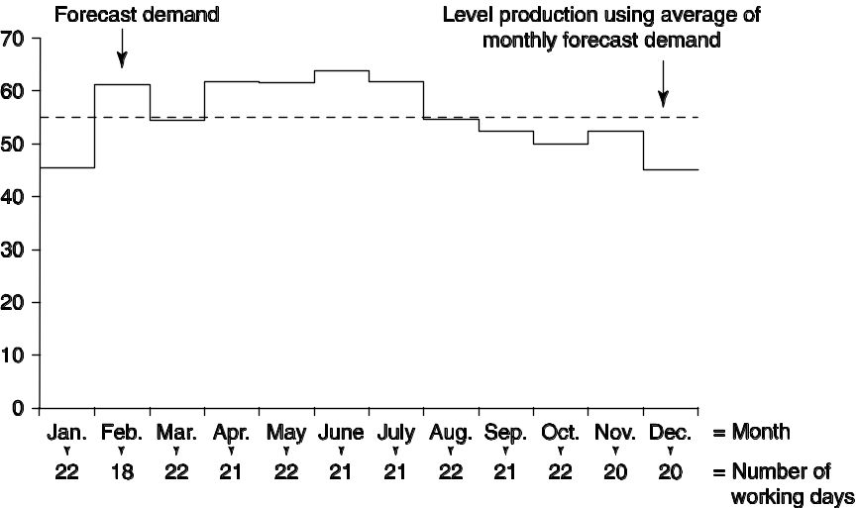
And, of course, customers use the system by finding the positions on the yield management curve that works for them. Sometimes this means shopping for tickets weeks in advance and taking the risk of a change
in plans, or going to the restaurant early, or finding and using those discount coupons. How much work do you want to do for a discount? It turns out that some people will not do the work necessary to use the system to their advantage.
Active Model Exercise
ACTIVE MODEL 13.1: Aggregate Planning
1. Each worker makes five units per day. If the number of workers is reduced from 10 to 9, dropping the daily capacity, what happens to the cost?
The cost actually drops to $54,465. This is due to drops in the amount of inventory that is maintained.
2. What regular time level minimizes the total cost?
39 units
3. How low can the regular daily capacity get before overtime will be required?
At 22 units per day (4.4 workers), overtime is required.
4. How low can the regular daily capacity get before there will not be enough capacity to meet the demand?
At 12 units per day (2.4 workers), demand cannot be met.
End-of-Chapter Problems
13.1 | Month | Production  Days | Forecast  Demand | Needed  Production  Each Day
 | Jan | 22 | 1,000 | 45.5
 | Feb | 18 | 1,100 | 61.1
 | Mar | 22 | 1,200 | 54.5
 | Apr | 21 | 1,300 | 61.9
 | May | 22 | 1,350 | 61.4
 | Jun | 21 | 1,350 | 64.3
 | July | 21 | 1,300 | 61.9
 | Aug | 22 | 1,200 | 54.5
 | Sep | 21 | 1,100 | 52.4
 | Oct | 22 | 1,100 | 50.0
 | Nov | 20 | 1,050 | 52.5
 | Dec | 20 | 900 | 45.0
 |  | 252 | 13,950 | 55.4  (on average)

13.2 (a) Plan 5
 | Month | Expected  Demand |  |  | Production  Days |  |  | Demand  Per Day
 | Jan | 900 |  |  | 22 |  |  | 41
 | Feb | 700 |  |  | 18 |  |  | 39
 | Mar | 800 |  |  | 21 |  |  | 38
 | Apr | 1,200 |  |  | 21 |  |  | 57
 | May | 1,500 |  |  | 22 |  |  | 68
 | Jun | 1,100 |  |  | 20 |  |  | 55
 |  |  | 6,200 |  |  | 124
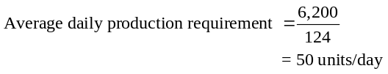
Constant workforce of 6 persons; subcontract to meet extra demand: Subcontract cost = $20/unit
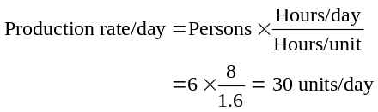
Month | Expected  Demand | Production  (@ 30/day) |  | Subcontract
Jan | 900 | 660 |  | 240
Feb | 700 | 540 |  | 160
Mar | 800 | 630 |  | 170
Apr | 1,200 | 630 |  | 570
May | 1,500 | 660 |  | 840
Jun | 1,100 | 600 |  | 500
 |  |  |  |  | 2,480
Plan 5 Cost analysis:
Regular production:
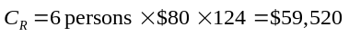
Subcontract cost @ $10/unit:
Total cost:
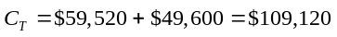(not preferable to Plan 2 at $105,152, but preferable to Plan 4 at $113,488).
(b) Plan 6 Constant workforce of 7 persons; subcontract to meet extra demand: Labor → 1.6 hours/unit
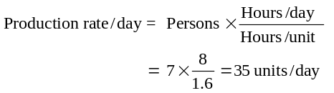
Month | Expected  Demand | Production  (@ 35/day) | Subcontract
Jan | 900 | 770 | 130
Feb | 700 | 630 | 70
Mar | 800 | 735 | 65
Apr | 1,200 | 735 | 465
May | 1,500 | 770 | 730
Jun | 1,100 | 700 | 400
 |  |  |  | 1,860
Plan 6 Cost analysis:
Regular production:
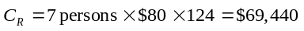
Subcontracting:
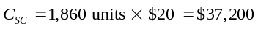
Total cost:
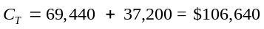
Plan 2 is still preferable, but Plan 6 has lower cost than Plan 5.
Comparing:
 | Plan 1 | Plan 2 | Plan 3 | Plan 4 | Plan 5 | Plan 6
Carrying
cost | 9,250 | 0 | 0 | 400 | 0 | 0
Reg. time | 99,200 | 75,392 | 99,200 | 79,360 | 59,520 | 69,440
Overtime | 0 | 0 | 0 | 33,728 | 49,600 | 0
Subcont. | 0 | 29,870 | 0 | 0 | 0 | 37,200
Hire | 0 | 0 | 9,000 | 0 | 0 | 0
Layoff | 0 | 0 | 9,600 | 0 | 0 | 0
Total cost | 108,450 | 105,152 | 117,800 | 113,488 | 109,120 | 106,640
Based simply upon total cost, Plan 2 is preferable. From a practi-cal viewpoint, Plans 1, 5, and 6 will likely have equivalent costs. Practical implementation of Plan 2 may, for example, require the employment of eight full-time employees, rather than seven full-time and one part-time employee. When several plans have roughly equivalent costs, other parameters gain importance—such as the amount of control one would have over production and ex-cess wear on equipment and personnel. Plan 3 should be avoided.

13.3 | Period | Expected Demand
 | 1 |  | 1,400
 | 2 |  | 1,600
 | 3 |  | 1,800
 | 4 |  | 1,800
 | 5 |  | 2,200
 | 6 |  | 2,200
 | 7 |  | 1,800
 | 8 |  | 1,400
 |  |  | 14,200

13.3 (cont’d)
 | Plan A
 |  | Production
 |  | (Result of
 |  | Previous | Inventory | Stockout |  | Hire | Layoff |  | Personnel
Period | Demand | Month) | (Units) | (Units) |  | (Units) | (Units) |  | Cost
1 (Jan) | 1,400 | 1,600 | 400 |  |  |  | 200 |  | $15,000 ←(cost to go from 1,600 in Jan to 1,400 in Feb)
2 (Feb) | 1,600 | 1,400 | 200 |  |  | 200 |  |  | 10,000 ←(cost to go from 1,400 in Feb to 1,600 in Mar)
3 (Mar) | 1,800 | 1,600 |  |  |  | 200 |  |  | 10,000
4 (Apr) | 1,800 | 1,800 |  |  |  |  |  |  | —
5 (May) | 2,200 | 1,800 |  | 400 |  | 400 |  |  | 20,000
6 (June) | 2,200 | 2,200 |  |  |  |  |  |  | —
7 (July) | 1,800 | 2,200 | 400 |  |  |  | 400 |  | 30,000
8 (Aug) | 1,400 | 1,800 | 800 |  |  |  | 400 |  | 30,000 ←(cost to go from 1,800 in August to 1,400 in Sept)
 |  |  | 1,800 | $400 | Total $115,000
 |  |  | @ $20 | @ $100 | Personnel Cost:
 |  |  | =$36,000 | =$40,000
Note: December demand was 1,600, and because our strategy is chasing prior-period demand, our January production is 1,600. So 200 units remain in inventory, and January production adds 200 units to this inventory, for a total of 400 units. Inventory units: Jan. 400 + Feb. 200 + July 400 + Aug. 800 (400 from July and 400 from August) = 1,800 units at $20 = $36,000. Stockout units: May 400 units at $100 = $40,000. Hiring and layoff costs = $115,000. Total costs = $36,000 + $40,000 + $115,000 = $191,000.

13.4 | Plan B
 | Period | Demand | Production | Ending Inv. | Subcon (Units) | Extra Cost
 | 0 |  |  | 200
 | 1 | 1,400 | 1,400 | 200 | — | $4,000
 | 2 | 1,600 | 1,400 | 0 | — | —
 | 3 | 1,800 | 1,400 | 0 | 400 | 30,000
 | 4 | 1,800 | 1,400 | 0 | 400 | 30,000
 | 5 | 2,200 | 1,400 | 0 | 800 | 60,000
 | 6 | 2,200 | 1,400 | 0 | 800 | 60,000
 | 7 | 1,800 | 1,400 | 0 | 400 | 30,000
 | 8 | 1,400 | 1,400 | 0 | —
 |  |  |  |  | Total Extra Cost: $214,000

13.5 (a)

Plan C
Period | Demand | Production* | Ending Inv. | Stockouts (Units) | Extra Cost
0 |  |  | 200
1 | 1,400 | 1,775 | 575 |  | $11,500
2 | 1,600 | 1,775 | 750 |  | 15,000
3 | 1,800 | 1,775 | 725 |  | 14,500
4 | 1,800 | 1,775 | 700 |  | 14,000
5 | 2,200 | 1,775 | 275 |  | 5,500
6 | 2,200 | 1,775 | 0 | 150 | 15,000
7 | 1,800 | 1,775 | 0 | 25 | 2,500
8 | 1,400 | 1,775 | 375 |  | 7,500
 |  |  |  | Total Extra Cost: $85,500

*(14,200/8) = 1,775 average. All other things being equal, it would appear that Plan C, with a cost of $85,500 and stockout costs ignored, should be recom-
mended over Plan A (cost = $224,000) or Plan B (cost = $214,000).

(b) Graph of Plan C
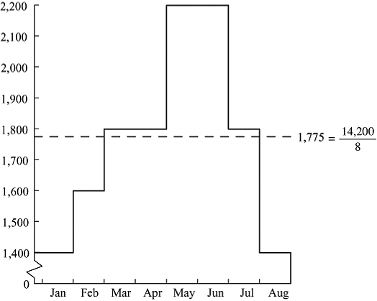

13.6 (a) Plan D: Maximum units in overtime = 0.20 × 1,600 = 320
Noting that the additional cost of a stockout is much greater than the sum of the additional costs for overtime plus inventory storage, one might “look ahead” and schedule overtime where possible. The resulting aggregate plan would be:
Plan D
 |  | Reg. | O.T. | End Inv. |  | Stockouts | Extra
Period | Demand | (Units) | (Units) | (Units) |  | (Units) | Cost
0 |  |  |  | 200
1 | 1,400 | 1,600 | — | 400 |  |  | $8,000
2 | 1,600 | 1,600 | — | 400 |  |  | 8,000
3 | 1,800 | 1,600 | — | 200 |  |  | 4,000
4 | 1,800 | 1,600 | — | — |  |  | 0
5 | 2,200 | 1,600 | 320 | — |  | 280 | 44,000
6 | 2,200 | 1,600 | 320 | — |  | 280 | 44,000
7 | 1,800 | 1,600 | 200 | — |  |  | 10,000
8 | 1,400 | 1,600 | — | 200 |  |  | 4,000
 |  |  |  |  | Total Extra Cost: $122,000

 |  | Reg. | O.T. | End Inv. |  | Stockouts | Extra
Period | Demand | (Units) | (Units) | (Units) |  | (Units) | Cost
0 |  |  |  | 200
1 | 1,400 | 1,600 | — | 400 |  |  | $8,000
2 | 1,600 | 1,600 | — | 400 |  |  | 8,000
3 | 1,800 | 1,600 | 80 | 280 |  |  | 9,600
4 | 1,800 | 1,600 | 320 | 400 |  |  | 24,000
5 | 2,200 | 1,600 | 320 | 120 |  |  | 18,400
6 | 2,200 | 1,600 | 320 | — |  | 160 | 32,000
7 | 1,800 | 1,600 | 200 | — |  |  | 10,000
8 | 1,400 | 1,600 | — | 200 |  |  | 4,000
 |  |  |  |  | Total Extra Cost: $114,000

(b) | Plan E
 | Period | Demand | Production | Subcont (Units) |  | Ending Inv. | Extra Cost
 | 0 |  |  |  |  | 200
 | 1 | 1,400 | 1,600 |  |  | 400 | $8,000
 | 2 | 1,600 | 1,600 |  |  | 400 | 8,000
 | 3 | 1,800 | 1,600 |  |  | 200 | 4,000
 | 4 | 1,800 | 1,600 |  |  |  | 0
 | 5 | 2,200 | 1,600 | 600 |  |  | 45,000
 | 6 | 2,200 | 1,600 | 600 |  |  | 45,000
 | 7 | 1,800 | 1,600 | 200 |  |  | 15,000
 | 8 | 1,400 | 1,600 |  |  | 200 | 4,000
 |  |  |  |  | Total Extra Cost: $129,000

All other things being equal, it would appear that Plan D, with a cost of $122,000, should be recommended over Plan E (cost = $129,000).
Note that of all the plans discussed, it would appear that Plan C, with a cost of $85,500, should be recommended over all others.
Production per person per day: 8 hr/person ÷ 4 hours/disk
Month | Expected Demand
Jul | 400
Aug | 500
Sep | 550
Oct | 700
Nov | 800
Dec | 700

13.7
Therefore, each person can produce 2 disks per day, or 40 disks per month.
(a) Aggregate plan, hiring/layoff only:
 |  | Beg. |  |  | Personnel
 |  | Inventory |  | Hours | Required |  |  | Production |  |  | Costs
 | Unit | Over | Units | Required | at 20 days | Personnel | Units | Over |  | Layoff | Hire: 40
Period | Demand | (or Short) | Required | at 4 each | at 8 hrs | on staff | Produced | (or Short) | Hire $40 | $80 | Layoff: 80
Jun |  | 150 |  |  |  | 8
Jul | 400 | 150 | 250 | 1,000 | 6.25 | 6 | 240 | –10 |  | 2 | $160
Aug | 500 | –10 | 510 | 2,040 | 12.75 | 13 | 520 | 10* | 7 |  | $280
Sep | 550 | 10 | 540 | 2,160 | 13.50 | 14 | 560 | 20* | 1 |  | $40
Oct | 700 | 20 | 680 | 2,720 | 17.00 | 17 | 680 | 0 | 3 |  | $120
Nov | 800 | 0 | 800 | 3,200 | 20.00 | 20 | 800 | 0 | 3 |  | $120
Dec | 700 | 0 | 700 | 2,800 | 17.50 | 17 | 680 | –20 |  | 3 | $240
 |  |  |  |  |  |  |  |  | Total Cost: $960

* Inventory (August = 10 and Sept. = 20) = 30 × 8 = $240
Inventory Cost = 30 × 8 = $240
Hiring/Layoff Cost = 960
$1,200
Note: In computing cost, we assumed that, if the capacity of a fraction of a worker was needed (was excess), one worker was hired (layed off). Solution by POM for Windows, in which the increase cost is $1 per unit and the decrease cost is $2 per unit, yields a similar result, with a total extra cost of $890.
1,580 × ($72 – $48) = $37,920 = Extra total (OT) cost + $560 holding cost = $38,480

(b) Aggregate plan, overtime only:
 |  | Production | Production | Ending | Inventory Holding Cost
Period | Demand | (Regular) | (Overtime) | Inv. | @ $8/unit/month
Jun |  |  |  | 150
Jul | 400 | 320 |  | 70 | 560
Aug | 500 | 320 | 110
Sep | 550 | 320 | 230
Oct | 700 | 320 | 380
Nov | 800 | 320 | 480
Dec | 700 | 320 | 380
 |  | Total 1,580 |  |  | $560

↑ ↑ 
Units made on $72 = 4 hr $48 = 4 hr
overtime (OT) each × $18 each × $12

13.8 Calculating added costs for various planning options to complement Problem 13.7:
- Holding: $8/unit/month
- Subcontracting: $80/unit
- Overtime: $24/unit ($18/hour over 8 hours:
$72 – $48 = $24)
- Hiring: $1/unit
- Layoff: $2/unit
Your strategy is one that involves hiring 5 workers in August and 5 more in October, as follows:
 |  | Beg. |  |  | Personnel |  |  |  |  |  | Costs
 |  | Inventory |  | Hours | Required |  |  | Production |  |  | Inventory = $8
 | Unit | Over | Units | Required | at 20 days | Personnel | Units | Over | Hire | Layoff | Hire: 40
Period | Demand | (or Short) | Required | at 4 each | at 8 hrs | on staff | Produced | (or Short) | $40 | $80 | Layoff: 80
Jun |  | 150 |  |  |  | 8
Jul | 400 | 150 | 250 | 1,000 | 8.00 | 8 | 320 | 70 |  | 0 | $560 = (70 × 8)
Aug | 500 | 70 | 430 | 1,720 | 13.00 | 13 | 520 | 90 | 5 |  | $920 = (90 × 8) + 200
Sep | 550 | 90 | 460 | 1,840 | 13.00 | 13 | 520 | 60 | 0 |  | $480 = (60 × 8)
Oct | 700 | 60 | 640 | 2,560 | 18.00 | 18 | 720 | 80 | 5 |  | $840 = (80 × 8) + 200
Nov | 800 | 80 | 720 | 2,880 | 18.00 | 18 | 720 | 0 | 0 |  | —
Dec | 700 | 0 | 700 | 2,800 | 18.00 | 18 | 720 | 20 | 0 | 0 | $160 = (20 × 8)
 |  |  |  |  |  |  |  | Total Extra Cost: $2,960

Students should be encouraged to consider the long-range implications of any aggregate planning strategy involving planned hiring/firing with respect to the development of an appropriate labor pool, etc.
13.9
Month | Expected Demand
Jul | 1,000
Aug | 1,200
Sep | 1,400
Oct | 1,800
Nov | 1,800
Dec | 1,600

(a) Plan A: Minimum rate of 1,000/month, subcontract for
additional.
Plan A
Period | Demand | Production | Ending Inv. | Subcont. (Units) | Extra Cost
Jul | 1,000 | 1,000 | 0 | — | 0
Aug | 1,200 | 1,000 | 0 | 200 | 12,000
Sep | 1,400 | 1,000 | 0 | 400 | 24,000
Oct | 1,800 | 1,000 | 0 | 800 | 48,000
Nov | 1,800 | 1,000 | 0 | 800 | 48,000
Dec | 1,600 | 1,000 | 0 | 600 | 36,000
 |  |  |  | Total Extra Cost: $168,000

If our object in comparing the plans is to identify
the elements of an optimal plan, we must consider the following:
 | Plan B: Vary workforce.
 | Plan B
 | Period | Demand | Production (Existing) | Hire (Units) | Layoffs (Units) | Extra Cost
 | Jul | 1,000 | 1,300 | — | 300 | $18,000
 | Aug | 1,200 | 1,000 | 200 |  | 6,000
 | Sep | 1,400 | 1,200 | 200 |  | 6,000
 | Oct | 1,800 | 1,400 | 400 |  | 12,000
 | Nov | 1,800 | 1,800 | — |  | —
 | Dec | 1,600 | 1,800 | — | 200 | 12,000
 |  |  |  |  | Total Extra Cost: $54,000

13.10 (a) | Plan C
 | Period | Demand | Production (Units) | Subcont. (Units) | Ending Inv. | Extra Cost
 | Jun |  |  |  | 300
 | Jul | 1,000 | 1,300 |  | 600 | $15,000
 | Aug | 1,200 | 1,300 |  | 700 | 17,500
 | Sep | 1,400 | 1,300 |  | 600 | 15,000
 | Oct | 1,800 | 1,300 |  | 100 | 2,500
 | Nov | 1,800 | 1,300 | 400 | 0 | 24,000
 | Dec | 1,600 | 1,300 | 300 | 0 | 18,000
 |  |  |  |  | Total Extra Cost: $92,000

(b) Plan D: Maximum units in overtime = 0.20 × 1,300 = 260
Plan D
 |  |  |  |  | Subcont. | Idle Time
Month | Demand | Reg. (Units) | O.T. (Units) | End Inv. | Units | (Units) | Extra Cost
Jul | 1,000 | 1,300 |  | 180 |  | 120 | $11,700
Aug | 1,200 | 1,300 |  | 180 |  | 100 | 10,500
Sep | 1,400 | 1,300 |  | 80 |  |  | 2,000
Oct | 1,800 | 1,300 | 260 | 0 | 160 |  | 20,000
Nov | 1,800 | 1,300 | 260 | 0 | 240 |  | 24,800
Dec | 1,600 | 1,300 | 260 | 0 | 40 |  | 12,800
 |  |  |  |  | Total Extra Cost: $81,800

Plans A, B, and D begin with zero initial inventory,
Plan C begins with an initial inventory of 300 units. It is therefore inappropriate to compare directly the results of Plan C with those of Plans A, B, and D.
(b) Plan B is best because of cost. But note that production is only 8,500 units.

In addition, we can assume that the warehouse constraint introduced in Plan D would have affected the costs of Plan A and Plan C had it been in effect in those plans.
What one can say is that the aggregate planning options should be utilized as available, in the following order:
- Carryover of inventory: $25/unit
- Overtime: $40/unit
- Hiring: $30/unit
- Layoff: $60/unit
- Subcontracting: $60/unit
- Stockout: $100/unit
13.11 Initial data:
Costs (per unit)
Reg Time | = | $ 30
Overtime | = | $ 15 extra per unit
Subcontract | = | not available
Holding | = | 10
Stockout | = | 50
Hiring | = | 40
Layoffs | = | 80

Initial inventory | = | 0
Units last period | = | 1,500

(a) The Chase plan:
 |  |  |  | Reg. Time
Period | Demand |  |  | Production |  | Change | Hiring |  | Layoffs
Quarter 1 | 1,400 |  |  | 1,400 |  | –100 | 0 |  | 100
Quarter 2 | 1,200 |  |  | 1,200 |  | –200 | 0 |  | 200
Quarter 3 | 1,500 |  |  | 1,500 |  | 300 | 300 |  | 0
Quarter 4 | 1,300 |  |  | 1,300 |  | –200 | 0 |  | 200
Total |  | 5,400 |  |  | 5,400 |  |  | 300 |  | 500
 |  |  |  | @$30/unit |  |  | @$40/unit |  | @$80/unit
Cost |  |  |  | $162,000 |  |  | $12,000 |  | $40,000
Total Cost: $214,000

Overtime production = $0
Subcontract = $0 and
Inventory holding and shortage cost = $0
(b) The Level plan:
 |  |  |  | Reg. Time
Period | Demand |  |  | Production |  |  |  | Inventory | Holding |  |  |  | Shortage |  |  |  | Change | Hiring |  |  |  | Layoffs
Quarter 1 | 1,400 |  |  | 1,350 |  |  |  | –50 | 0 |  |  |  | 50 |  |  |  | –150 | 0 |  |  |  | 150
Quarter 2 | 1,200 |  |  | 1,350 |  |  |  | 100 | 100 |  |  |  | 0 |  |  |  | 0 | 0 |  |  |  | 0
Quarter 3 | 1,500 |  |  | 1,350 |  |  |  | –50 | 0 |  |  |  | 50 |  |  |  | 0 | 0 |  |  |  | 0
Quarter 4 | 1,300 |  |  | 1,350 |  |  |  | 0 | 0 |  |  |  | 0 |  |  |  | 0 | 0
Total |  | 5,400 | * |  |  | 5,400 |  |  |  |  | 100 |  |  |  | 100 |  |  |  |  | 0 |  |  |  | 150
Cost |  |  |  |  | $162,000 |  |  |  |  | $1,000 |  |  |  | $5,000 |  |  |  |  | $0 |  |  |  | $12,000
Total Cost: $180,000
* (5,400/4) = 1,350 = average demand.

(c) A Level plan will cost $180,000, while a Chase plan will cost $214,000.
13.12 Initial data:
Costs (per case) |  |  |  | Initial inventory | = | 0 |  | Quarter | Forecast Demand
Reg time | = | $30 |  | Production last period | = | 1300 |  | 1 | 1,800 cases
Overtime | = | 45 |  |  |  |  |  | 2 | 1,100 cases
Subcontract | = | 60 |  |  |  |  |  | 3 | 1,600 cases
Holding | = | 40 |  |  |  |  |  | 4 | 900 cases
Stockout | = | 150
Hiring | = | 40
Layoff | = | 80

(a) Plan A: Chase plan

 |  |  |  | Reg. Time |  |  |  |  |  |  |  | Hiring |  |  |  | Layoffs
Period | Demand |  |  | Production |  |  |  |  |  | Change |  | (Increase) |  |  |  | (Decrease)
Quarter 1 | 1,800 |  |  | 1,800 |  |  |  |  |  | 500 |  | 500 |  |  |  | 0
Quarter 2 | 1,100 |  |  | 1,100 |  |  |  |  |  | –700 |  | 0 |  |  |  | 700
Quarter 3 | 1,600 |  |  | 1,600 |  |  |  |  |  | 500 |  | 500 |  |  |  | 0
Quarter 4 | 900 |  |  | 900 |  |  |  |  |  | –700 |  | 0 |  |  |  | 700
Total |  | 5,400 |  |  |  | 5,400 |  |  |  |  |  |  |  | 1,000 |  |  |  | 1,400
Cost |  |  |  |  | $162,000 |  |  |  |  |  |  |  | $40,000 |  |  |  | $112,000
Total Cost: $314,000

(b) Plan B: Level Strategy of 1,350 cases
 |  |  |  |  | Reg. Time |  |  |  |  |  |  |  |  |  |  |  |  |  |  | Hiring |  |  |  | Layoffs
Period | Forecast |  |  |  | Production |  |  |  | Inventory | Holding |  |  |  |  | Shortage |  |  |  | Change | (Increase) |  |  |  | (Decrease)
Quarter 1 | 1,800 |  |  |  | 1,350 |  |  |  | –450 | 0 |  |  |  |  | 450 |  |  |  | 50 | 50 |  |  |  | 0
Quarter 2 | 1,100 |  |  |  | 1,350 |  |  |  | –200 | 0 |  |  |  |  | 200 |  |  |  | 0 | 0 |  |  |  | 0
Quarter 3 | 1,600 |  |  |  | 1,350 |  |  |  | –450 | 0 |  |  |  |  | 450 |  |  |  | 0 | 0 |  |  |  | 0
Quarter 4 |  | 900 |  |  | 1,350 |  |  |  | 0 |  | 0 |  |  |  | 0 |  |  |  | 0 | 0 |  |  |  | 0
Total |  | 5,400 |  |  |  |  | 5,400 |  |  |  |  |  | 0 |  |  |  | 1,100 |  |  |  |  | 50 |  |  |  | 0
Cost |  |  |  |  |  | $162,000 |  |  |  |  |  | $0 |  |  |  | $165,000 |  |  |  |  | $2,000 |  |  |  | $0
Total Cost: $329,000

An alternative way of viewing this problem assigns the same costs to regular time production and to hiring (i.e., $162,000 and $2,000) but places holding cost at $28,000 and shortage cost at $67,500. Total cost is then $259,500.
(c) Plan C: Level Strategy at 1200, plus subcontracting:
 |  |  |  | Reg. Time |  |  |  | Overtime |  |  | Subcontract |  |  |  |  |  |  |  |  | Hiring |  |  |  | Layoffs
Period | Forecast |  |  | Production |  |  |  | Production |  |  | Production |  |  | Inventory | Holding |  |  |  | Change | (Increase) |  |  |  | (Decrease)
Quarter 1 | 1,800 |  |  | 1,200 |  |  |  |  |  |  | 600 |  |  | 0 | 0 |  |  |  | –100 | 0 |  |  |  | 100
Quarter 2 | 1,100 |  |  | 1,200 |  |  |  |  |  |  |  |  |  | 100 | 100 |  |  |  | 0 | 0 |  |  |  | 0
Quarter 3 | 1,600 |  |  | 1,200 |  |  |  |  |  |  | 300 |  |  | 0 | 0 |  |  |  | 0 | 0 |  |  |  | 0
Quarter 4 | 900 |  |  | 1,200 |  |  |  |  |  |  |  |  |  | 300 | 300 |  |  |  | 0 | 0 |  |  |  | 0
Total |  | 5,400 |  |  |  | 4,800 |  | 0 |  |  | 900 |  |  |  |  |  | 400 |  |  |  | 0 |  |  |  |  | 100
Cost |  |  |  |  | $144,000 |  |  |  | $0 |  |  | $54,000 |  |  |  | $16,000 |  |  |  | $0 |  |  |  |  | $8,000
Total Cost: $222,000

(d, e) The boss implements Plan C because it is not only the lowest cost, but has the added advantage of providing steady employment for the employees after the initial first quarter layoff.
13.13 Assuming that back orders are not permitted, the solution is:
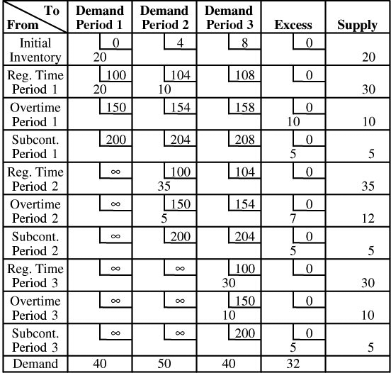
Total cost = $11,790

13.14 Assuming that back orders are not permitted, the solution is:
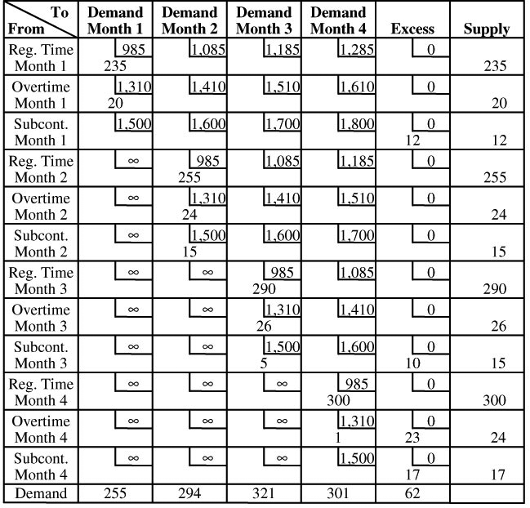
Total cost = $1,186,810
13.15 Assuming that back orders are not permitted, the solution is:
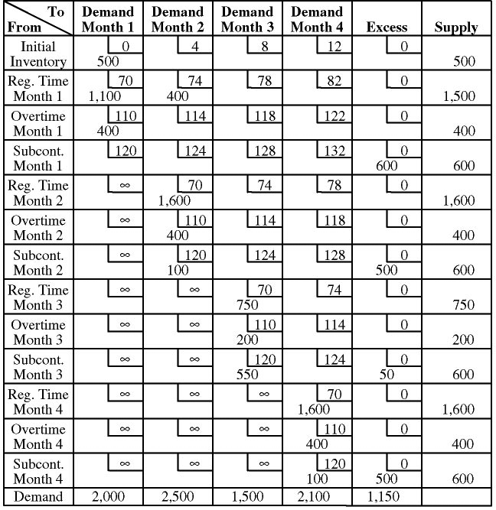
Total cost = $627,100

An alternative solution is:
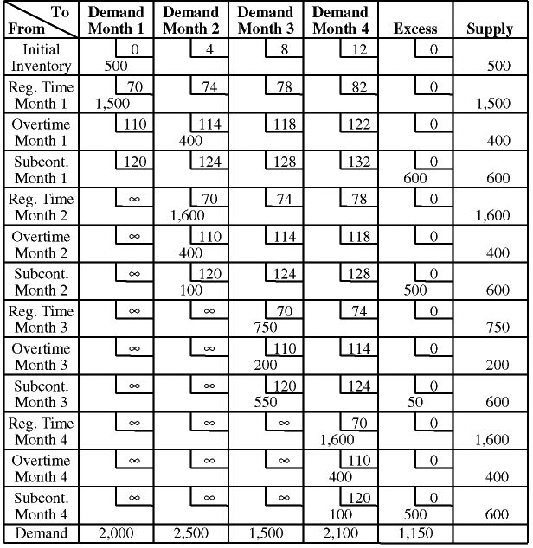
Total cost = $627,100
13.16 Assuming that back orders are not permitted, the solution is:
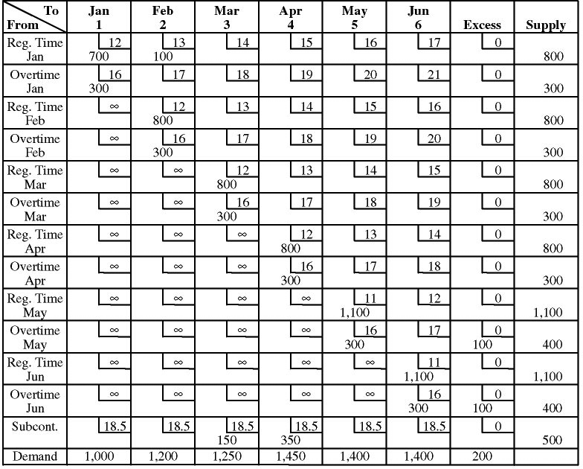
Total cost = $100,750
13.17 (a) The cost matrix and the optimal plan are shown below:
Cost Matrix: | Quarter 1 | Quarter 2 | Quarter 3 | Quarter 4 | Ending Inv. | Supply
Beg. inv. | 0.2 | 0.4 | 0.6 | 0.8 | 1 | 250
Reg. time 1 | 1 | 1.2 | 1.4 | 1.6 | 1.8 | 400
Overtime 1 | 1.5 | 1.7 | 1.9 | 2.1 | 2.3 | 80
Subcontract 1 | 2 | 2.2 | 2.4 | 2.6 | 2.8 | 100
Reg. time 2 | 1.5 | 1 | 1.2 | 1.4 | 1.6 | 400
Overtime 2 | 2 | 1.5 | 1.7 | 1.9 | 2.1 | 80
Subcontract 2 | 2.5 | 2 | 2.2 | 2.4 | 2.6 | 100
Reg. time 3 | 2 | 1.5 | 1 | 1.2 | 1.4 | 800
Overtime 3 | 2.5 | 2 | 1.5 | 1.7 | 1.9 | 160
Subcontract 3 | 3 | 2.5 | 2 | 2.2 | 2.4 | 100
Reg. time 4 | 2.5 | 2 | 1.5 | 1 | 1.2 | 400
Overtime 4 | 3 | 2.5 | 2 | 1.5 | 1.7 | 80
Subcontract 4 | 3.5 | 3 | 2.5 | 2 | 2.2 | 100
Demand | 500 | 750 | 900 | 450 |  | 2600/3050

Optimal Plan: | Quarter 1 | Quarter 2 | Quarter 3 | Quarter 4 | Ending Inv. | Dummy
Beg. inv. | 100 | 150
Reg. time 1 | 400
Overtime 1 |  | 80
Subcontract 1 |  |  |  |  |  | 100
Reg. time 2 |  | 400
Overtime 2 |  | 80
Subcontract 2 |  |  |  |  |  | 100
Reg. time 3 |  |  | 800
Overtime 3 |  | 40 | 100 |  |  | 20
Subcontract 3 |  |  |  |  |  | 100
Reg. time 4 |  |  |  | 400
Overtime 4 |  |  |  | 50 |  | 30
Subcontract 4 |  |  |  |  |  | 100
 | 500 | 750 | 900 | 450

Optimal cost = $2,641
(b) The cost of the optimal plan is $2,641. Alternate opti-mal solutions are possible.
(c) All regular time is used.
(d) 40 units are backordered in Quarter 2 and produced on overtime in Quarter 3 at a cost of $.50 each for a total cost of $20.
Total cost = $90,850
13.18 Assuming that back orders are not permitted, one solution,
of multiple optional solutions, is:
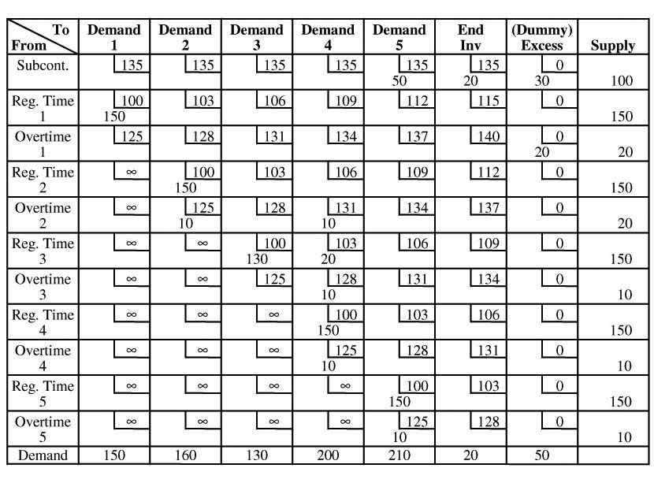
Note: Ending inventory of 20 units held to period 6 each require the additional carrying cost of $3 if produced on regular or overtime. Because they are optimally pro-duced by subcontracting (which is available, at any time), no additional carrying cost is incurred.
13.19
(a) | Method → Produce to demand (let workforce vary)
 | Shortages: Lost sales — Shortages not carried from month to month
 | All months → |  |  |  |  |  |  | $1,000 | $1,300 | $1,800 | $200 | $0 | $0 | $0
 |  |  | Capacities |  |  |  |  |  |  |  | Units
 | Month | Demnd | Regtm | Ovrtm |  | Subcon |  | Regtm | Ovrtm | Subcon | Holdng | Shortg | Increase | Decrease
 | Init | 0 | 0 | 0 |  | 0
 | Jan | 255 | 235 | 20 |  | 12 |  | 235 | 20 | 0 | 0 | 0 | 0 | 0
 | Feb | 294 | 255 | 24 |  | 16 |  | 255 | 24 | 15 | 0 | 0 | 20 | 0
 | Mar | 321 | 290 | 26 |  | 15 |  | 290 | 26 | 5 | 0 | 0 | 35
 | Apr | 301 | 300 | 24 |  | 17 |  | 300 | 1 | 0 | 0 | 0 | 10 | 0
 | May | 330 | 300 | 30 |  | 17 |  | 300 | 30 | 0 | 0 | 0 | 0 | 0
 | June | 320 | 290 | 28 |  | 19 |  | 290 | 28 | 2 | 0 | 0 | 0 | 10
 | July | 345 | 300 | 30 |  | 19 |  | 300 | 30 | 15 | 0 | 0 | 10 | 0
 | Aug | 340 | 290 | 30 |  | 20 |  | 290 | 30 | 20 | 0 | 0 | 0 | 10
 | Tot | 2,506 | 2,260 | 212 |  | 135 |  | 2,260 | 189 | 57 | 0 | 0 | 75 | 20
 |  |  |  | Subtotal Costs |  |  |  | 2,260,000 | 245,700 | 102,600 | 0 | 0 | 0 | 0

Summary Table
Units
Type | Summary Table  Units | Cost
Regtm | 2,260 | $2,260,000
Ovrtm | 189 | $245,700
Subcon | 57 | $102,600
Holdng | 0 | $0
Shortg | 0 | $0
Increase | 75 | $0
Decrease | 20 | $0
 | Total cost = $2,608,300

(b) | Method → Produce to demand (let workforce vary)
 | Shortages: Lost sales — Shortages not carried from month to month
 | All pds → |  |  |  |  | $1,000 | $1,300 | $1,800 | $200 | $0 | $0 | $0
 |  |  | Capacities |  |  |  |  |  | Units
 | Month | Demnd | Regtm | Ovrtm | Subcon | Regtm | Ovrtm | Subcon | Holdng | Shortg | Increase | Decrease
 | Init | 0 | 0 | 0 | 0
 | Jan | 255 | 275 | 20 | 12 | 255 | 0 | 0 | 0 | 0 | 0 | 0
 | Feb | 294 | 275 | 24 | 16 | 275 | 19 | 0 | 0 | 0 | 20 | 0
 | Mar | 321 | 275 | 26 | 15 | 275 | 26 | 15 | 0 | 5 | 0 | 0
 | Apr | 301 | 275 | 24 | 17 | 275 | 24 | 2 | 0 | 0 | 0 | 0
 | May | 330 | 275 | 30 | 17 | 275 | 30 | 17 | 0 | 8 | 0 | 0
 | June | 320 | 275 | 28 | 19 | 275 | 28 | 17 | 0 | 0 | 0 | 0
 | July | 345 | 275 | 30 | 19 | 275 | 30 | 19 | 0 | 21 | 0 | 0
 | Aug | 340 | 275 | 30 | 20 | 275 | 30 | 20 | 0 | 15 | 0 | 0
 | Tot | 2,506 | 2,200 | 212 | 135 | 2,180 | 187 | 90 | 0 | 49 | 20 | 0
 |  |  |  | Subtotal Costs |  | 2,180,000 | 243,100 | 162,000 | 0 | 0 | 0 | 0

 | Summary Table
Type | Units | Cost
Regtm | 2,180 | $2,180,000
Ovrtm | 187 | $243,100
Subcon | 90 | $162,000
Holdng | 0 | $0
Shortg | 49 | $0
Increase | 20 | $0
Decrease | 0 | $0
Total cost = $2,585,100, or about $50,000 savings

(c) | Method → Produce to demand (let workforce vary)
 | Shortages: Lost sales — Shortages not carried from month to month
 | All months → |  |  |  |  |  |  | $1,000 | $1,400 | $1,800 | $200 | $0 | $0 | $0
 |  |  | Capacities |  |  |  |  |  |  |  | Units
 | Month | Demnd | Regtm |  | Ovrtm |  | Subcon | Regtm | Ovrtm | Subcon | Holdng | Shortg | Increase | Decrease
 | Init | 0 | 0 |  | 0 |  | 0
 | Jan | 255 | 235 |  | 20 |  | 12 | 235 | 20 | 0 | 0 | 0 | 0 | 0
 | Feb | 294 | 255 |  | 24 |  | 16 | 255 | 24 | 15 | 0 | 0 | 20 | 0
 | Mar | 321 | 290 |  | 26 |  | 15 | 290 | 26 | 5 | 0 | 0 | 35 | 0
 | Apr | 301 | 300 |  | 24 |  | 17 | 300 | 1 | 0 | 0 | 0 | 10 | 0
 | May | 330 | 300 |  | 30 |  | 17 | 300 | 30 | 0 | 0 | 0 | 0 | 0
 | June | 320 | 290 |  | 28 |  | 19 | 290 | 28 | 2 | 0 | 0 | 0 | 10
 | July | 345 | 300 |  | 30 |  | 19 | 300 | 30 | 15 | 0 | 0 | 10 | 0
 | Aug | 340 | 290 |  | 30 |  | 20 | 290 | 30 | 20 | 0 | 0 | 0 | 10
 | Tot | 2,506 | 2,260 |  | 212 |  | 135 | 2,260 | 189 | 57 | 0 | 0 | 75 | 20
 |  |  |  |  | Subtotal Costs |  |  | 2,260,000 | 264,600 | 102,600 | 0 | 0 | 0 | 0

Summary Table—Overtime Costs: $1400
Type | Units | Cost
Regtm | 2,260 | $2,260,000
Ovrtm | 189 | $264,600
Subcon | 57 | $102,600
Holdng | 0 | $0
Shortg | 0 | $0
Increase | 75 | $0
Decrease | 20 | $0
Total cost = $2,627,200

There is no change in the solution other than higher cost.
Method → Produce to demand (let workforce vary)
Shortages: Lost sales — Shortages not carried from month to month
All months → |  |  |  |  |  |  | $1,000 | $1,200 | $1,800 | $200 | $0 | $0 | $0
 |  | Capacities |  |  |  |  |  |  |  | Units
Month | Demnd | Regtm | Ovrtm |  | Subcon |  | Regtm | Ovrtm | Subcon | Holdng | Shortg | Increase | Decrease
Init | 0 | 0 | 0 |  | 0
Jan | 255 | 235 | 20 |  | 12 |  | 235 | 20 | 0 | 0 | 0 | 0 | 0
Feb | 294 | 255 | 24 |  | 16 |  | 255 | 24 | 15 | 0 | 0 | 20 | 0
Mar | 321 | 290 | 26 |  | 15 |  | 290 | 26 | 5 | 0 | 0 | 35 | 0
Apr | 301 | 300 | 24 |  | 17 |  | 300 | 1 | 0 | 0 | 0 | 10 | 0
May | 330 | 300 | 30 |  | 17 |  | 300 | 30 | 0 | 0 | 0 | 0 | 0
June | 320 | 290 | 28 |  | 19 |  | 290 | 28 | 2 | 0 | 0 | 0 | 10
July | 345 | 300 | 30 |  | 19 |  | 300 | 30 | 15 | 0 | 0 | 10 | 0
Aug | 340 | 290 | 30 |  | 20 |  | 290 | 30 | 20 | 0 | 0 | 0 | 10
Tot | 2,506 | 2,260 | 212 |  | 135 |  | 2,260 | 189 | 57 | 0 | 0 | 75 | 20
 |  |  | Subtotal Costs |  |  |  | $2,260,000 | $226,800 | $102,600 | 0 | 0 | 0 | 0

Summary Table—Overtime Costs: $1,200
Type | Units | Cost
Regtm | 2,260 | $2,260,000
Ovrtm | 189 | $226,800
Subcon | 57 | $102,600
Holdng | 0 | $0
Shortg | 0 | $0
Increase | 75 | $0
Decrease | 20 | $0
 | Total cost = $2,589,400

Again there is no change in the solution other than
a lower cost.
13.20 (a, b) Aggregate plan and its costs
 | Estimated |  | Reg. time
 | Billable |  | billable | Reg. Time |  |  | “Overtime” |  |  | Overtime |  |  | Forrester |  |  | Forrester
Month | hours | CPAs | hours | cost |  |  | hours |  |  | cost |  |  | hours |  |  | cost
Jan | 600 | 4 | 640 | $20,000 |  |  | 0 |  |  | $0 |  |  | 0 |  |  | 0
Feb | 500 | 4 | 640 | $20,000 |  |  | 0 |  |  | $0 |  |  | 0 |  |  | $0
Mar | 1,000 | 4 | 640 | $20,000 |  |  | 320 |  |  | $20,000 |  |  | 40 |  |  | $5,000
Apr | 1,200 | 4 | 640 | $20,000 |  |  | 320 |  |  | $20,000 |  |  | 240 |  |  | $30,000
May | 650 | 4 | 640 | $20,000 |  |  | 10 |  |  | $625 |  |  | 0 |  |  | $0
June | 590 | 4 | 640 | $20,000 |  |  | 0 |  |  | $0 |  |  | 0 |  |  | $0
 |  |  |  |  | $120,000 |  |  | 650 |  |  | $40,625 |  |  | 280 |  |  | $35,000
Total cost = $120,000 + $40,625 + $35,000 = $195,625

(c) The accounting business, as everyone recognizes, has one extremely busy season (during March and April tax preparation time), and several less hectic but still very active months (such as when quarterly payments are due). Could another CPA be justified at $60,000 per year in salary? Based solely on savings in overtime costs and the cost of Forrester, it would appear to be unclear, as savings total only $30,625. On the other hand, current employees are drawing overtime pay of $40,000 (averaging $10,000 each) during March and April, and may be very unhappy over the loss of income. We would have to carefully examine the other 6 months to see if hiring is merited.
13.21
(a) |  | Estimated |  | Reg. Time
 |  | Billable |  | Billable | Reg. Time |  |  |  | Overtime |  |  |  | Overtime |  |  |  | Forrester |  |  |  |  |  | Forrester
 | Month | hours | CPAs | Hours | Cost |  |  |  | Hours |  |  |  | Cost |  |  |  | Hours |  |  |  |  |  | Cost
 | Jan | 660 | 5 | 800 | $25,000 |  |  |  | 0 |  |  |  | $0 |  |  |  | 0 |  |  |  |  |  | $0
 | Feb | 550 | 5 | 800 | $25,000 |  |  |  | 0 |  |  |  | $0 |  |  |  | 0 |  |  |  |  |  | $0
 | Mar | 1,100 | 5 | 800 | $25,000 |  |  |  | 300 |  |  |  | $18,750 |  |  |  | 0 |  |  |  |  |  | $0
 | Apr | 1,320 | 5 | 800 | $25,000 |  |  |  | 400 |  |  |  | $25,000 |  |  |  |  | 120 |  |  |  |  | $15,000
 | May | 715 | 5 | 800 | $25,000 |  |  |  | 0 |  |  |  | $0 |  |  |  | 0 |  |  |  |  |  | $0
 | June | 649 | 5 | 800 | $25,000 |  |  |  | 0 |  |  |  | $0 |  |  |  | 0 |  |  |  |  |  | $0
 |  |  |  |  |  | $150,000 |  |  |  | 700 |  |  |  | $43,750 |  |  |  |  | 120 |  |  |  |  | $15,000
Total cost = $150,000 + $43,750 + $15,000 = $208,750

(b) With the increase in business, 5 accountants appear to be necessary. There is still a need for overtime during the tax season (about the same as in Problem 13.20), but there is a big savings in Forrester’s pay (which
is double that of overtime for a regular employee). What Cohen needs to do is find additional accounting activities that his staff can work on during the
“off-peak” season.
13.22 (a) Current model—Single price at Southeastern Airlines
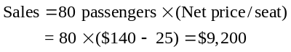
(b) Proposed model—two price points

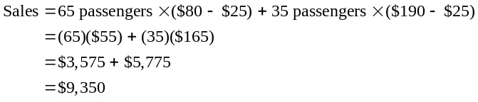The new approach is only slightly better in
terms of sales but provides a more compli-
cated ticketing system. The issue of fairness is
always paramount.
Additional Homework Problems
Here are solutions to additional homework problems
(13.23–13.26) that appear on our Web site, at www.pearsonglobaleditions.com/myomlab.
13.23 The intent of the authors is that this problem be solved using the transportation problem format. Assuming that back orders are not permitted, the solution is:
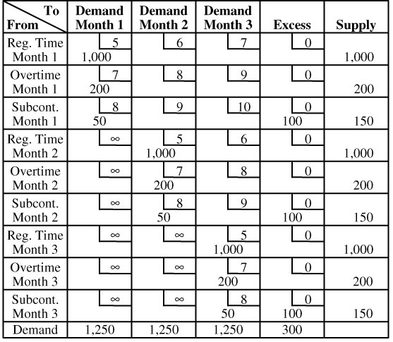
Total cost = $20,400
13.24 Assuming that back orders are not permitted, the solution is:
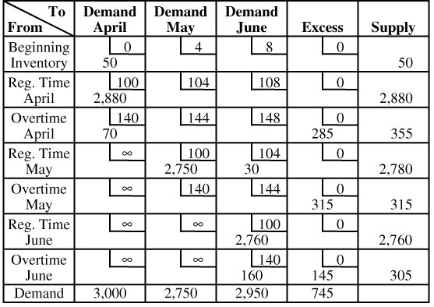
Total cost = $874,320
Total cost = $308,125
13.25 Even though back orders are permitted, note they are not
used. One of the multiple optimal solutions is:
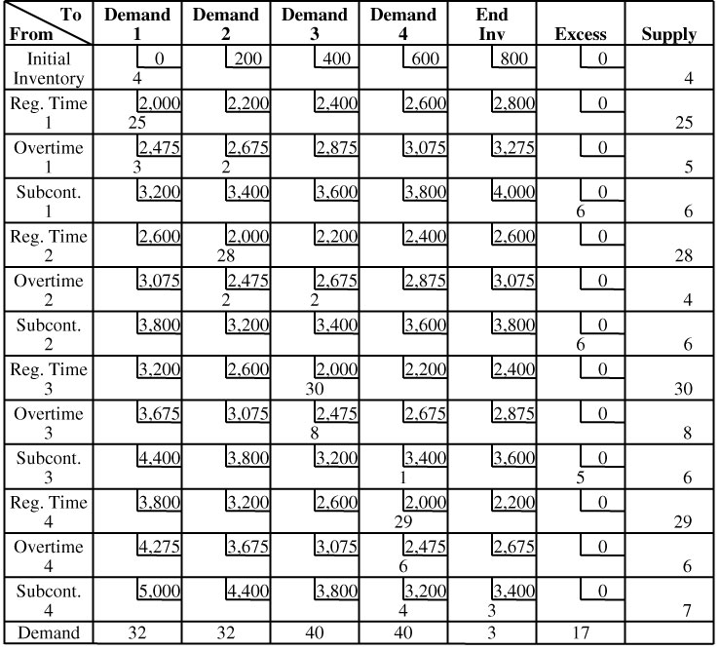
Note: Ending inventory of 3 units held to period 5 each
require the additional carrying cost of $200. You may wish to convey this hint to students when assigning the problem.
13.26
Costs (per refrigerator)
Reg time | = | $48 = 4 hr × $12/hr.
Overtime | = | 72 = 4 hr × $18/hr.
Subcontract | = | 80
Holding | = | 8
Stockout | = | 0
Hiring | = | 40
Layoff | = | 80

Forecast | Demand
Jan | 400
Feb | 500
Mar | 550
Apr | 700
May | 800
June | 700

Initial inventory | 250
Units last period | 320

(a) |  | Reg Time
 | Period | Demand |  |  | Production |  |  |  | Inventory | Holding |  |  |  | Shortage |  |  | Change | Increase |  |  |  | Decrease
 | Jan | 400 |  |  | 400 |  |  |  | 250 | 250 |  |  |  | 0 |  |  | 80 | 80 |  |  |  | 0
 | Feb | 500 |  |  | 500 |  |  |  | 250 | 250 |  |  |  | 0 |  |  | 100 | 100 |  |  |  | 0
 | Mar | 550 |  |  | 550 |  |  |  | 250 | 250 |  |  |  | 0 |  |  | 50 | 50 |  |  |  | 0
 | Apr | 700 |  |  | 700 |  |  |  | 250 | 250 |  |  |  | 0 |  |  | 150 | 150 |  |  |  | 0
 | May | 800 |  |  | 800 |  |  |  | 250 | 250 |  |  |  | 0 |  |  | 100 | 100 |  |  |  | 0
 | June | 700 |  |  | 700 |  |  |  | 250 | 250 |  |  |  | 0 |  |  | –100 | 0 |  |  |  | 100
 | Total |  | 3650 |  |  |  | 3650 |  |  |  |  | 1500 |  |  | 0 |  |  |  |  | 480 |  |  |  | 100
 | Cost |  |  |  |  | $175,200 |  |  |  |  | $12,000 |  |  |  | $0 |  |  |  | $19,200 |  |  |  | $8,000
 | Total Cost | $214,400

(b) Each employee produces 2 units per day. So,
2 × 10 employees × 20 days = 400 units per period
 | Forecast |  |  | Reg Time
Period | Demand |  |  | Production |  |  |  | Inventory | Holding |  |  |  | Shortage |  |  |  | Change | Increase |  |  |  | Decrease
Jan | 400 |  |  | 400 |  |  |  | 250 | 250 |  |  |  | 0 |  |  |  | 80 | 80 |  |  |  | 0
Feb | 500 |  |  | 400 |  |  |  | 150 | 150 |  |  |  | 0 |  |  |  | 0 | 0 |  |  |  | 0
Mar | 550 |  |  | 400 |  |  |  | 0 | 0 |  |  |  | 0 |  |  |  | 0 | 0 |  |  |  | 0
Apr | 700 |  |  | 400 |  |  |  | –300 | 0 |  |  |  | 300 |  |  |  | 0 | 0 |  |  |  | 0
May | 800 |  |  | 400 |  |  |  | –700 | 0 |  |  |  | 700 |  |  |  | 0 | 0 |  |  |  | 0
June | 700 |  |  | 400 |  |  |  | –1000 | 0 |  |  |  | 1000 |  |  |  | 0 | 0 |  |  |  | 0
Total |  | 3650 |  |  |  | 2400 |  |  |  |  | 400 |  |  | 2000 |  |  |  |  |  | 80 |  |  | 0
Cost |  |  |  |  | $115,200 |  |  |  |  | $3,200 |  |  |  |  | $0 |  |  |  | $3,200 |  |  |  | $0
Total Cost | $121,600

(c) Plan B is certainly less expensive, but over the six months Bell Refrigeration has a shortage of 2000 refrigerators . . . about half of its sales. The loss suggests this is not a good plan

Case Studies
SOUTHWESTERN UNIVERSITY: G
1
This case provides the student with quantitative information to develop an aggregate capacity plan, but, as often occurs in services, demand is so variable that there are not many viable staffing alternatives. Students may also be frustrated by the lack of detailed data on the nature of service demand and the resources required to meet demand. Even with these drawbacks, the student should be able to gain insight into the aggregate planning problem and help the chief justify his personnel requests. Students may want to talk with the police department at their own university to see how it handles similar problems.
1. Which variations in demand for police services should be con-
sidered in an aggregate plan for resources? Which variations
can be handled with short-term scheduling adjustments?
An aggregate plan should set full-time staffing levels; estimate part-time and overtime needs for budget purposes; determine times of the year for training, vacations, and other nonessential duties; and establish an agreed-upon level of police services for the university community (i.e., What role is the police officer to play? What response time to calls for service is appropriate? What services should be provided?). Short-term scheduling adjustments can be made for different days of the week, shifts, and special events.
2. Evaluate the current staffing plan. What does it cost? Are
26 officers sufficient to handle the normal workload?
Cost of current staffing plan:
Salaries:
26 officers × $28,000 per year | = $728,000
Overtime:
2,400 hours per year × $18 per hour | = $43,200
Subcontractors:
40 officers × 9 hours × $18 per hour ×
5 football games per year | = $32,400
25 part-timers × 9 hours × $9 per hour ×
5 football games per year | = $10,125
 |  | $813,725

Normal workload during fall and spring semesters:
 | Weekday | Weekend | 7-day Average
1st shift | 5 | 4 | 4.7
2nd shift | 5 | 6 | 5.3
3rd shift | 6 | 8 | 6.6
 |  |  |  | 16.6

Number of 24-hour positions each week = 16.6/3 = 5.5
Number of persons required = 5.5 positions
× 5 persons/position
= 27.6 persons
Normal workload during the summer:
 | Weekday | Weekend | 7-day Average
1st shift | 2.5 | 2 | 2.4
2nd shift | 2.5 | 3 | 2.7
3rd shift | 3 | 4 | 3.3
 |  |  |  | 8.4

Number of 24-hour positions each week = 8.4/3 = 2.8
Number of persons required = 2.8 positions × 5 persons/position
= 14 persons
Twenty-six officers is more than enough to handle the normal workload during the three summer months. However, during the
remaining nine months of the year, the police department is al-
most two persons short. Obviously, some overtime is currently
being used to meet the demands of the normal workweek.
3. What would be the additional cost of the chief’s proposal? How would you suggest that the chief justify his request?
Salary: 4 officers × $28,000 per year = $112,000
Overtime: no additional cost, as subcontracting and overtime costs are the same.
To justify his proposal, the chief should point out that two
positions (representing $56,000) are needed to pursue the uni-versity’s request for more crime prevention, safety, and health programs. The other two positions could save up to $18,720 in
overtime premiums (total OT of 2,400 hours minus football game OT of 1,360 hours times $18 per hour) and are needed to maintain the desired level of police services. On a per hour basis, the salaried services are more cost effective than using overtime or subcontracting (@ $18/hour).
4. How much does it currently cost the university to provide police services for football games? What would be the pros and cons of subcontracting this work completely to outside law enforcement agencies?
Cost of police officers for football games:
18 officers work 8 hours overtime @ $18/hr
8 officers work 16 hours overtime @ $18/hr
40 outside officers work 9 hours @ $18/hr
25 part-timers work 9 hours @ $9/hr
5 football games per year
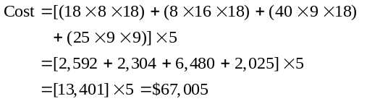
Subcontracting security for football games would relieve the weary campus police and allow them to perform their normal duties more effectively. However, football security is highly visible, and the absence of campus police may hurt their image in the university community and rob them of the opportunity to work closely with law enforcement personnel from agencies in a noncrisis situation. It may also be difficult for the university to maintain the same level of control over subcontracted work, especially in terms of discretionary treatment of students and alumni.
In terms of cost, it is doubtful that the work could be subcontracted as cheaply as it is currently performed because the cost of supervisory and managerial personnel would have to be included in the package (and currently no supervisors or managers are paid overtime for their work).
5. Can you propose any other alternatives?
Many of the innovative suggestions for handling the variability in demand for services involve using part-time workers. Police officers require extensive training, so this alternative usually means hiring off-duty police officers from other agencies. Under these circumstances, the hours that off-duty officers can moonlight are limited, and, except for football Saturdays, may be hard to schedule (i.e., all part-time agencies are busy at the same time). Another way to handle part-time or seasonal requirements for work is to find complementary work for the full-time employees that follows a different demand pattern. In this case, the nonpeak period for police services falls during the summer months. What other university services increase during those months? Perhaps the idled officers could be used as campus guides during summer orientation, as aides for the summer camps and other summer programs held on campus, or as part of the grounds crew. At least one small private college utilizes its police officers in this expanded fashion. It certainly increases the officers’ involvement with the university community.
ANDREW-CARTER, INC.
2
This case presents some of the basic concepts of aggregate planning by the transportation method. The case involves solving a
rather complex set of transportation problems. Four different configurations of operating plants have to be tested. The solutions, although requiring relatively few iterations to optimality, involve degeneracy if solved manually.
The costs are:
 | Total | Total | Total
Configuration | Variable Cost | Fixed Cost | Cost
All plants operating | $179,730 | $41,000 | $220,730
1 & 2 operating, 3 closed | 188,930 | 33,500 | 222,430
1 & 3 operating, 2 closed | 183,430 | 34,000 | 217,430
2 & 3 operating, 1 closed | 188,360 | 33,000 | 221,360

The lowest weekly total cost, operating plants 1 and 3 with 2 closed, is $217,430. This is $3,300 per week ($171,600 per year) or 1.5% less than the next most economical solution, operating all 3 plants. Closing a plant without expanding capacity of the remaining plants means unemployment. The optimum solution, using plants 1 and 3, indicates overtime production of 4,000 units at 3 and 0 overtime at 1. The all-plant optima have no use of overtime and include substantial idle regular time capacity: 11,000 units (55%) in plant 2 and either 5,000 units in 1 (19% of capacity) or 5,000 in 3 (20% of capacity). The idled capacity versus unemployment question is an interesting, nonquantitative aspect of the case and could lead to discussion of the forecasts for the housing market and thus the plant’s product.
The optimum producing and shipping pattern is:
From | To (Amount)
Plant 1 (R.T.) | W2 (13,000); W4 (14,000)
Plant 3 (R.T.) | W1 (5,000); W3 (11,000); W4 (1,000); W5 (8,000)
Plant 3 (O.T.) | W1 (4,000)

There are three alternative optimal producing and shipping patterns.
Getting the solution manually should not be attempted.
It will take eight tableaux to do the “All Plants” configuration, with degeneracy appearing in the seventh tableau; the “1 & 2” configuration takes five tableaux, etc. It is strongly suggested that POM for Windows, Excel, or other software be used.
Additional Case Study*
CORNWELL GLASS
Entering the data provided into software, then toggling the pure strategies and trying them yields the following costs:
Plan 1 (smooth production): $849,077
Plan 2 (meet demand exactly): $104,575
Plan 3 (produce 1,900 as base, then use
OT and subcontracting): $82,858
At this point, the question is, can we do better with trial and error? A better solution follows.
* This case is found on our Companion Web site,
www.pearsonglobaleditions.com/heizer.

Aggregate Planning
Time periods 52
Shortages: Back orders—Carry shortages from period to period
All pds → |  | 1,900 | 0 | 0 | $0 | $8.00 | $10 | $0.12 | $20.0 | $5.63 | $15.73
 |  |  | Schedule |  |  |  |  | Units
Pd | Demnd | Regtm | Ovrtm | Subcon | Regtm | Ovrtm | Subcon | Holdng | Shortg | Incres | Decres
Init | 73 | 1,900 | 0 | 0
April 15 | 1,829 | 1,900 | 250 | 0 | 1,900 | 250 | 0 | 394 | 0 | 0 | 0
22 | 1,820 | 1,900 | 250 | 0 | 1,900 | 250 | 0 | 724 | 0 | 0 | 0
29 | 1,887 | 1,900 | 250 | 0 | 1,900 | 250 | 0 | 987 | 0 | 0 | 0
May 6 | 1,958 | 1,900 | 250 | 0 | 1,900 | 250 | 0 | 1,179 | 0 | 0 | 0
13 | 2,011 | 1,900 | 250 | 0 | 1,900 | 250 | 0 | 1,318 | 0 | 0 | 0
20 | 2,063 | 1,900 | 250 | 0 | 1,900 | 250 | 0 | 1,405 | 0 | 0 | 0
27 | 2,104 | 1,900 | 250 | 0 | 1,900 | 250 | 0 | 1,451 | 0 | 0 | 0
June 3 | 2,161 | 1,900 | 250 | 0 | 1,900 | 250 | 0 | 1,440 | 0 | 0 | 0
10 | 2,258 | 1,900 | 250 | 0 | 1,900 | 250 | 0 | 1,332 | 0 | 0 | 0
17 | 2,307 | 1,900 | 250 | 0 | 1,900 | 250 | 0 | 1,175 | 0 | 0 | 0
24 | 2,389 | 1,900 | 250 | 0 | 1,900 | 250 | 0 | 936 | 0 | 0 | 0
July 1 | 2,434 | 1,900 | 250 | 0 | 1,900 | 250 | 0 | 652 | 0 | 0 | 0
8 | 2,402 | 1,900 | 250 | 0 | 1,900 | 250 | 0 | 400 | 0 | 0 | 0
15 | 2,385 | 1,900 | 250 | 0 | 1,900 | 250 | 0 | 165 | 0 | 0 | 0
22 | 2,330 | 1,900 | 250 | 15 | 1,900 | 250 | 15 | 0 | 0 | 0 | 0
29 | 2,323 | 1,900 | 250 | 173 | 1,900 | 250 | 173 | 0 | 0 | 0 | 0
Aug. 5 | 2,317 | 1,900 | 250 | 167 | 1,900 | 250 | 167 | 0 | 0 | 0 | 0
12 | 2,222 | 1,900 | 250 | 72 | 1,900 | 250 | 72 | 0 | 0 | 0 | 0
19 | 2,134 | 1,900 | 234 | 0 | 1,900 | 234 | 0 | 0 | 0 | 0 | 0
26 | 2,065 | 1,900 | 165 | 0 | 1,900 | 165 | 0 | 0 | 0 | 0 | 0
Sept. 2 | 1,973 | 1,900 | 73 | 0 | 1,900 | 73 | 0 | 0 | 0 | 0 | 0
9 | 1,912 | 1,900 | 12 | 0 | 1,900 | 12 | 0 | 0 | 0 | 0 | 0
16 | 1,854 | 1,900 | 0 | 0 | 1,900 | 0 | 0 | 46 | 0 | 0 | 0
23 | 1,763 | 1,900 | 0 | 0 | 1,900 | 0 | 0 | 183 | 0 | 0 | 0
30 | 1,699 | 1,900 | 0 | 0 | 1,900 | 0 | 0 | 384 | 0 | 0 | 0
Oct. 7 | 1,620 | 1,900 | 0 | 0 | 1,900 | 0 | 0 | 664 | 0 | 0 | 0
14 | 1,689 | 1,900 | 0 | 0 | 1,900 | 0 | 0 | 875 | 0 | 0 | 0
21 | 1,754 | 1,900 | 0 | 0 | 1,900 | 0 | 0 | 1,021 | 0 | 0 | 0
28 | 1,800 | 1,900 | 207 | 0 | 1,900 | 207 | 0 | 1,328 | 0 | 0 | 0
Nov. 4 | 1,864 | 1,900 | 250 | 0 | 1,900 | 250 | 0 | 1,614 | 0 | 0 | 0
11 | 1,989 | 1,900 | 250 | 0 | 1,900 | 250 | 0 | 1,775 | 0 | 0 | 0
18 | 2,098 | 1,900 | 250 | 0 | 1,900 | 250 | 0 | 1,827 | 0 | 0 | 0
25 | 2,244 | 1,900 | 250 | 0 | 1,900 | 250 | 0 | 1,733 | 0 | 0 | 0
Dec. 2 | 2,357 | 1,900 | 250 | 0 | 1,900 | 250 | 0 | 1,526 | 0 | 0 | 0
9 | 2,368 | 1,900 | 250 | 0 | 1,900 | 250 | 0 | 1,308 | 0 | 0 | 0
16 | 2,387 | 1,900 | 250 | 0 | 1,900 | 250 | 0 | 1,071 | 0 | 0 | 0
23 | 2,402 | 1,900 | 250 | 0 | 1,900 | 250 | 0 | 819 | 0 | 0 | 0
30 | 2,418 | 1,900 | 250 | 0 | 1,900 | 250 | 0 | 551 | 0 | 0 | 0
Jan. 6 | 2,417 | 1,900 | 250 | 0 | 1,900 | 250 | 0 | 284 | 0 | 0 | 0
13 | 2,324 | 1,900 | 250 | 0 | 1,900 | 250 | 0 | 110 | 0 | 0 | 0
20 | 2,204 | 1,900 | 250 | 0 | 1,900 | 250 | 0 | 56 | 0 | 0 | 0
27 | 2,188 | 1,900 | 250 | 0 | 1,900 | 250 | 0 | 18 | 0 | 0 | 0
Feb. 3 | 2,168 | 1,900 | 250 | 0 | 1,900 | 250 | 0 | 0 | 0 | 0 | 0
10 | 2,086 | 1,900 | 186 | 0 | 1,900 | 186 | 0 | 0 | 0 | 0 | 0
17 | 1,954 | 1,900 | 54 | 0 | 1,900 | 54 | 0 | 0 | 0 | 0 | 0
24 | 1,877 | 1,900 | 0 | 0 | 1,900 | 0 | 0 | 23 | 0 | 0 | 0
Mar. 3 | 1,822 | 1,900 | 0 | 0 | 1,900 | 0 | 0 | 101 | 0 | 0 | 0
10 | 1,803 | 1,900 | 0 | 0 | 1,900 | 0 | 0 | 198 | 0 | 0 | 0
17 | 1,777 | 1,900 | 0 | 0 | 1,900 | 0 | 0 | 321 | 0 | 0 | 0
24 | 1,799 | 1,900 | 0 | 0 | 1,900 | 0 | 0 | 422 | 0 | 0 | 0
31 | 1,803 | 1,900 | 0 | 0 | 1,900 | 0 | 0 | 519 | 0 | 0 | 0
Apr. 7 | 1,805 | 1,900 | 0 | 0 | 1,900 | 0 | 0 | 614 | 0 | 0 | 0
Total | 107,544 | 98,800 | 8,931 | 427 | 98,800 | 8,931 | 427 | 32,949 | 0 | 0 | 0
 |  |  | Subtotal Costs → |  | 0 | 71,448 | 4,270 | 3,953.9 | 0 | 0 | 0
Total cost = $79,671.88

